## Enhanced skills management

|  |
| --- |
| **Key features:**   * Extends **Skills management** & **Skills certification** modules. * New **Skills** menu with following entries: * **Employees skills** *(all skills/employees lines in a treeview).* * **Skills needs** *(needs defined per skill/level globally or by department)*. * **Skills followup** *(manage skill progress per employee and check global progress at a glance).* |

**Manage all skills of all your employees at the same place with a filtered *(search panel)/*grouped treeview.**

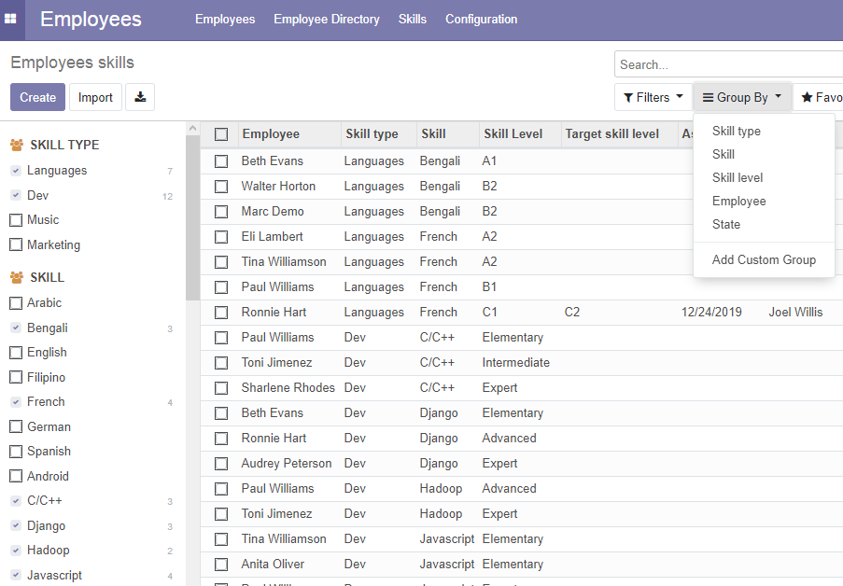

**Summarize all skills/levels in a pivot view.**

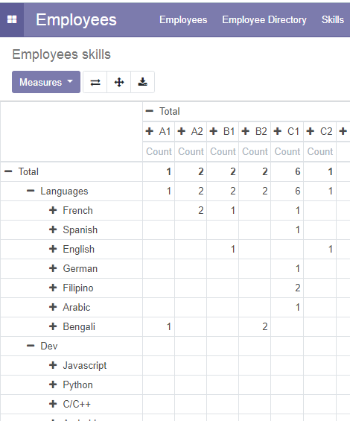

**Define individual skill development for employees and plan assessment.**

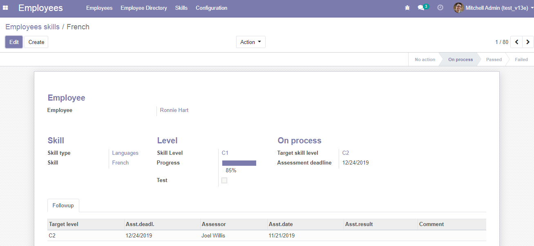

**Group all lines by state to follow your global skills development plan.**

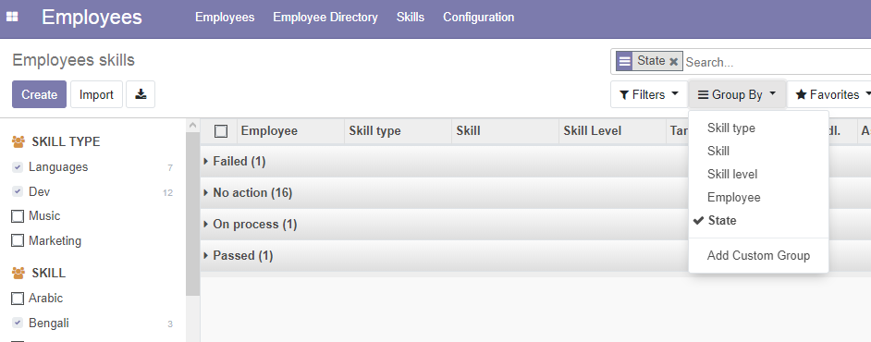

**Define assessors for skills**

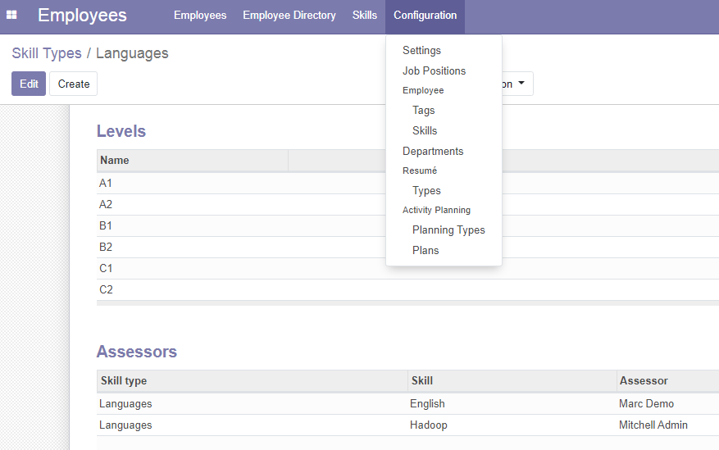

*You can set as many levels of subtask as you want.*

**SUPPORT**

**Please, report any bug to**[**iks.consultance@gmail.com**](mailto:iks.consultance@gmail.com)